**Randhirsingh Bhadoriya Mahavidyalaya**

**Umred Dist: Nagpur**



**Criterion-7.1.6**

**Out Side Envirnmental Promotional Activity**

**Geotagged Photos**

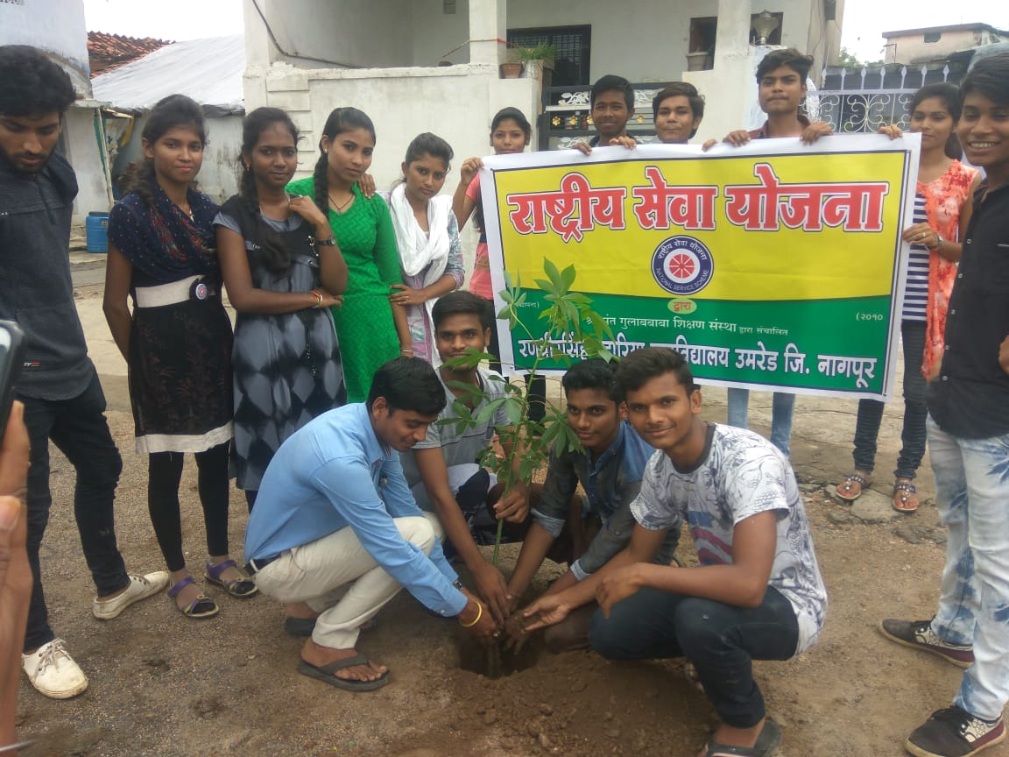

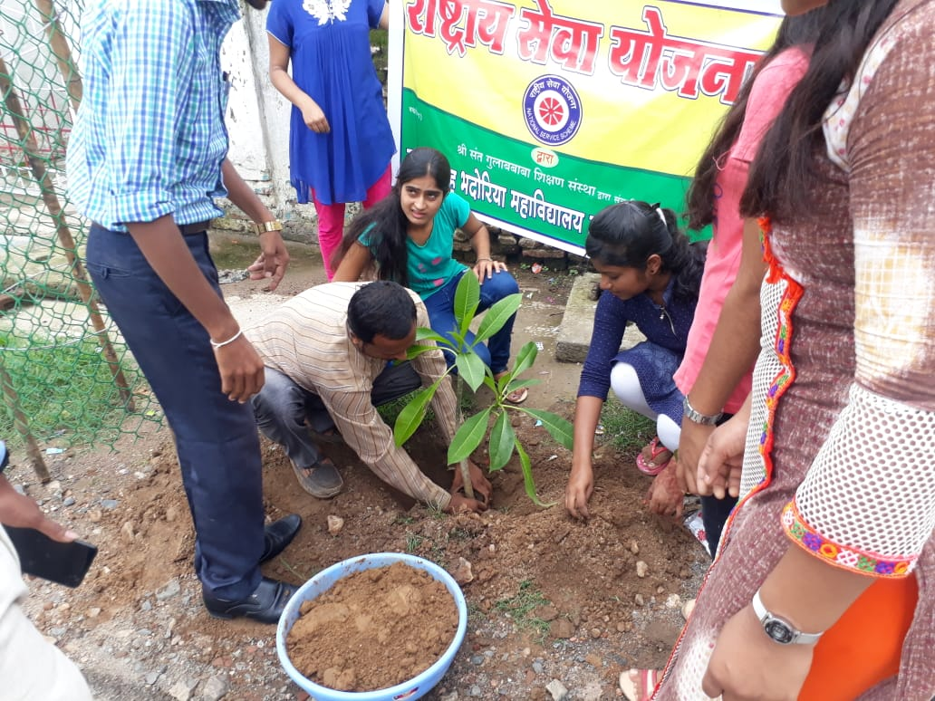

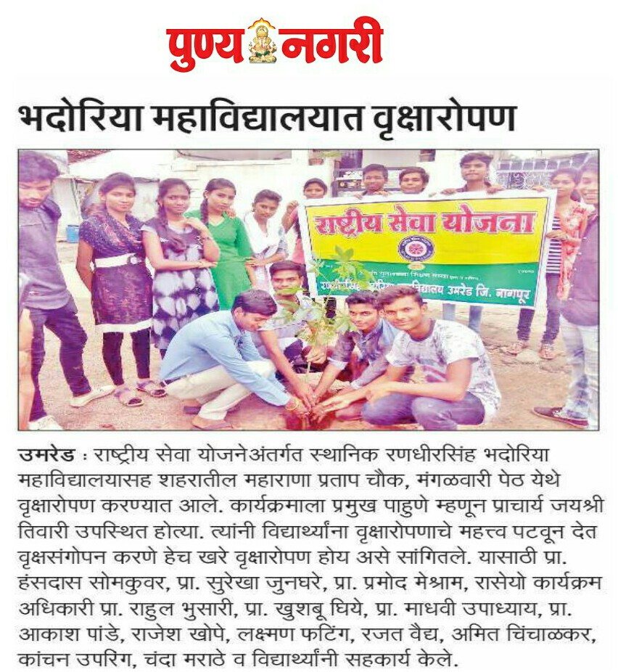

**5. Green Audit Done By Institute Internally**

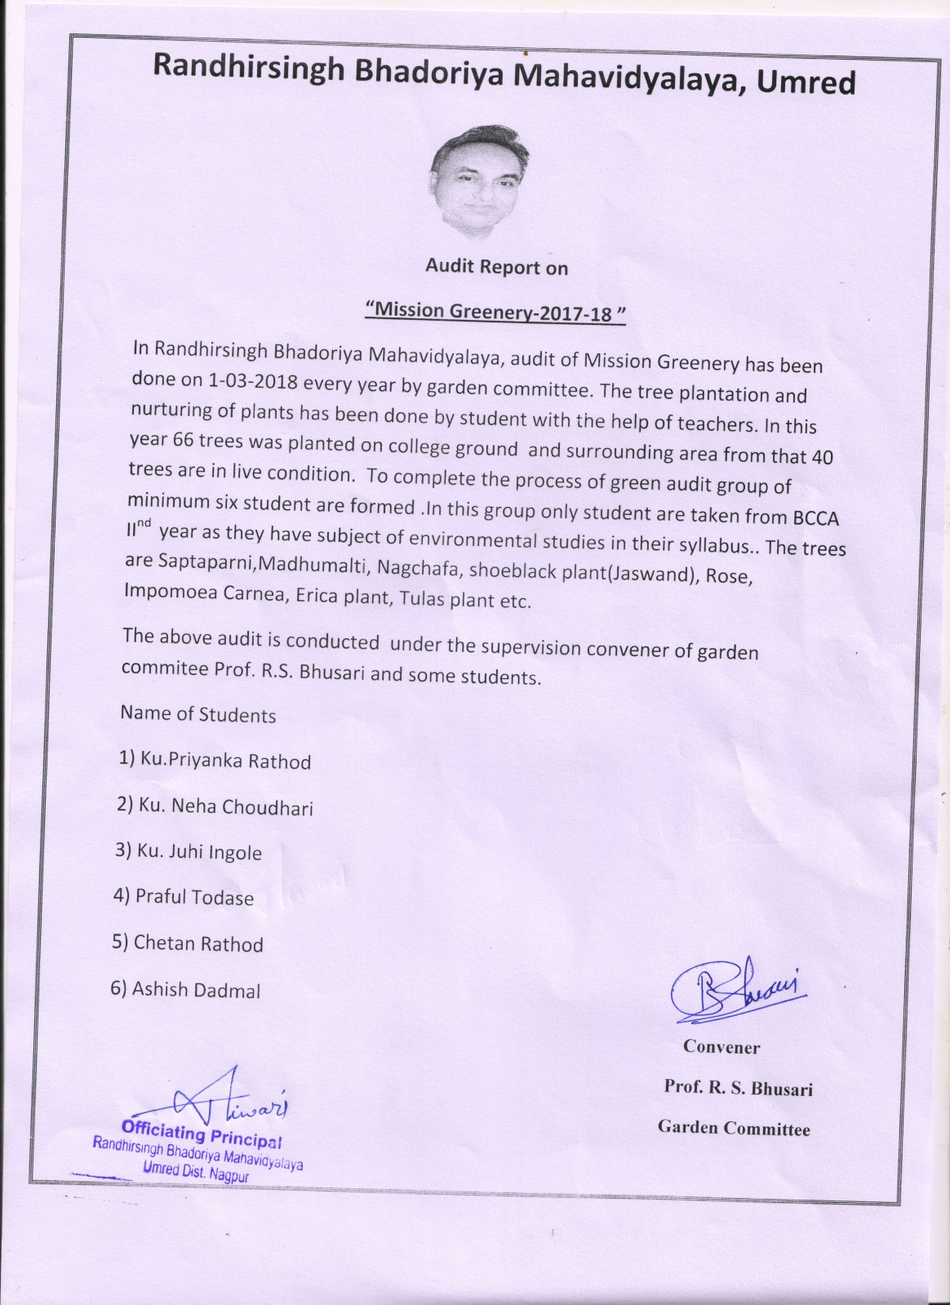

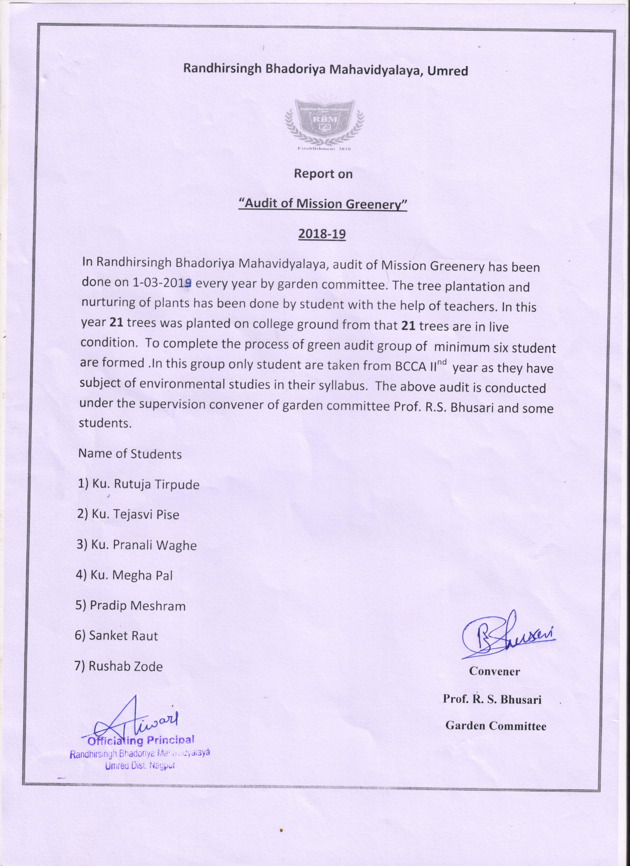

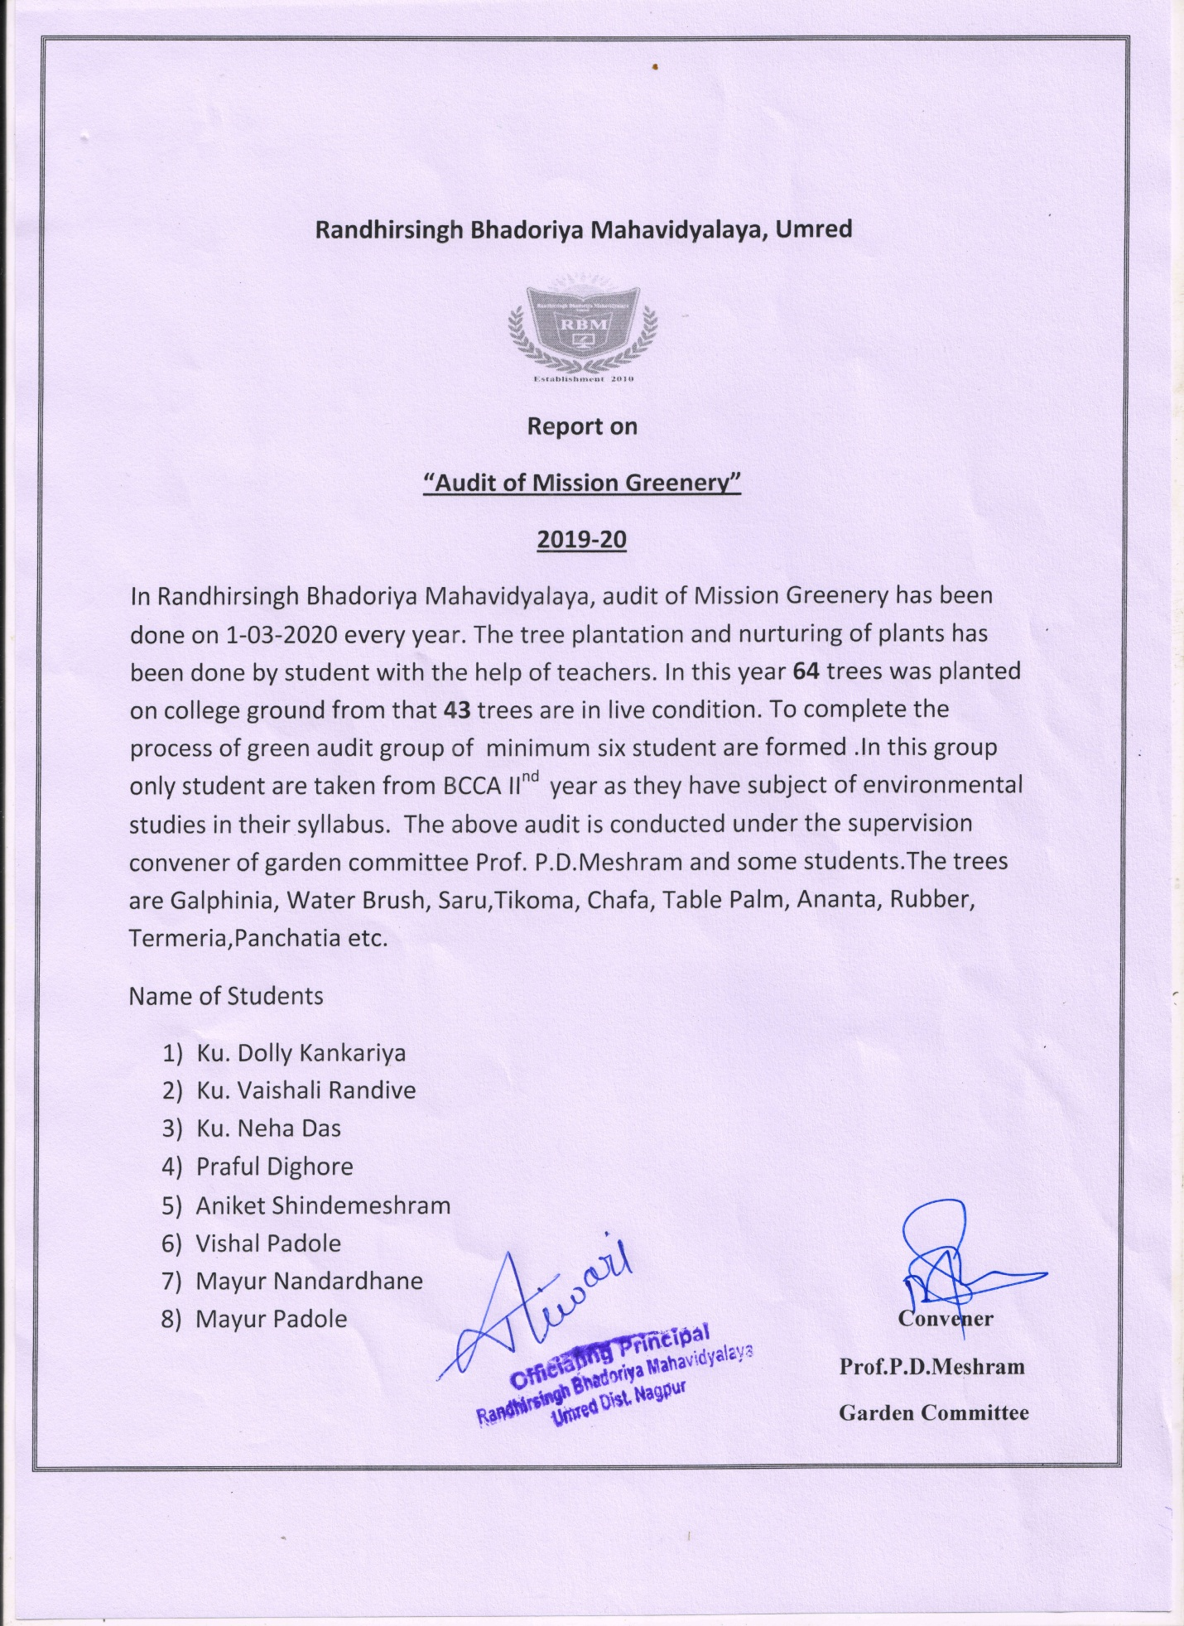

**4. Clean and green campus Recognitions/awards**

